The motor transport enterprise (ATP) received orders from

four (n = 4) enterprises P1 - P4 for the carriage of goods. available

the ATP car park is 20 units. To carry out transportation by ATP

allocates cars in multiples of 4 units. function of general

profits of ATP from transportation at enterprises, depending on the amount

cars allocated to their address, given in the form of table 7.1.

Using the dynamic programming method, determine

the best option for distributing cars between enterprises in order to

maximizing the ATP profits from the provision of cargo transportation services.

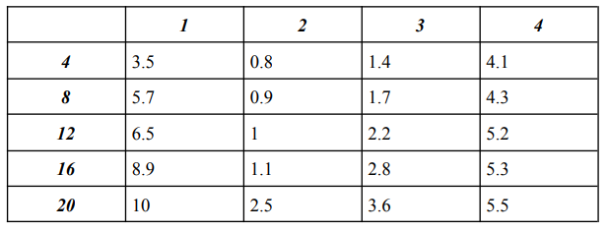

**Input**:

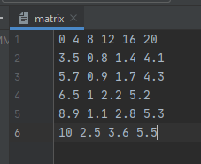

**Result:**

